Project Summary – Swagger UI

Table of Contents

Introduction 1

Rest 1

What is Swagger UI? 2

Swagger documentation 3

Modeling 3

Sequence Diagram 3

Activity Diagram 4

Class Diagram 5

Challenges for Swagger UI project 6

Competitors comparison 7

Swagger UI main contributors 8

# Introduction

## Rest

Representational state transfer (REST) is a software architecture style consisting of guidelines and best practices for creating scalable web services.

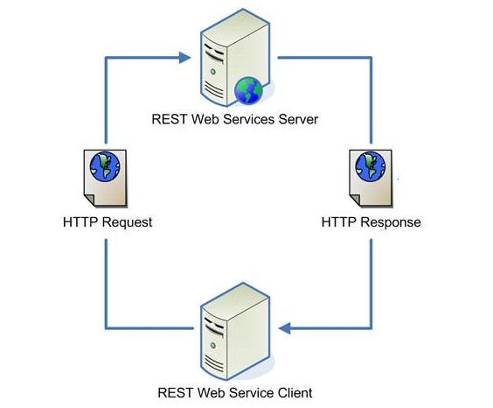

* **Problem**: describing the different APIs url and parameters.
* **Solution**: Swagger UI

# What is Swagger UI?

* Define a standard interface for describing APIs.
* Allows both humans and computers to discover and understand the capabilities of the service without access to source code.
* Similar to what interfaces have done for lower-level programming, Swagger removes the guesswork in calling the service.
* Swagger is made up of three components:
* Server: hosts the REST APIs that you want to use.
* Swagger Server: holds the API specification.
* Swagger UI Client: Reads a description of the APIs from the Swagger Server and renders it as a web-page and an interactive sandbox to play with the APIs.

# Swagger documentation

* Swagger specification repository – provides references for swagger related documentation and tools.
* Repository – src/main/html/index.html - the main swagger ui html page.
* Src/main/javascript/Swaggerui.js – the main javascript file for swagger.

# Modeling

Modeling the Swagger UI helped us to understand better the design, flow and components of Swagger UI.

## Sequence Diagram

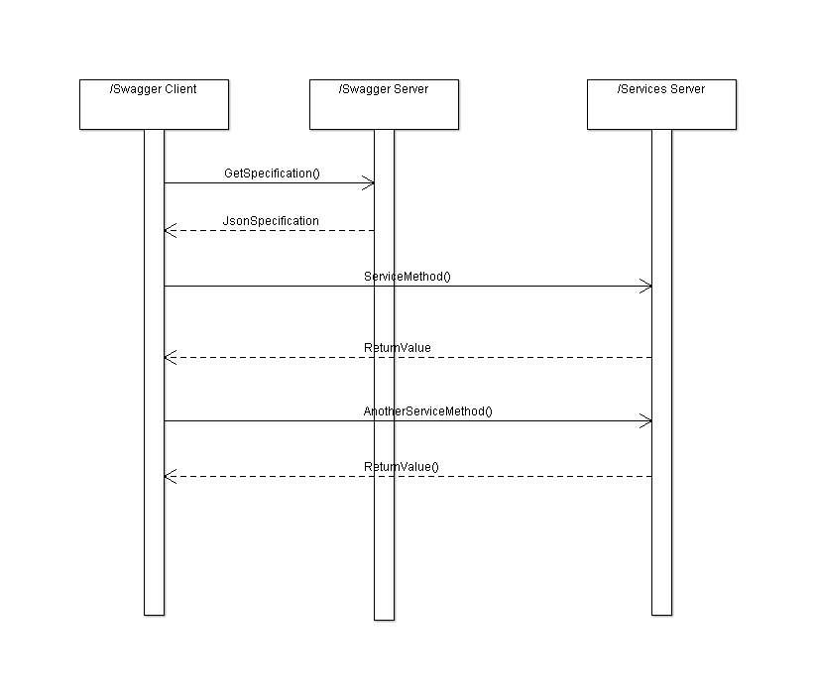

## Activity Diagram

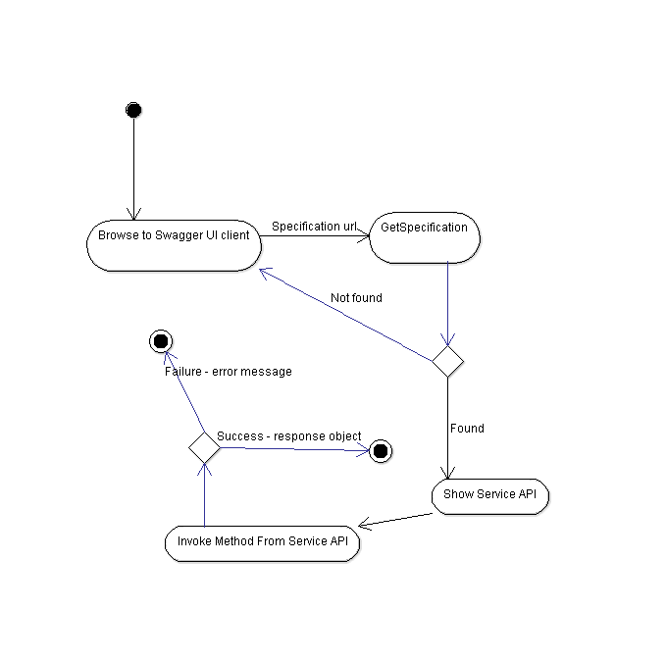

## Class Diagram

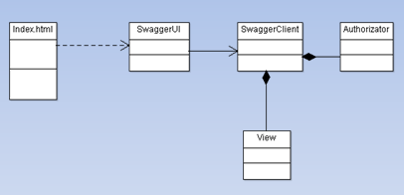

# Challenges for Swagger UI project

* **Security Bugs**: Cross Site Scripting(XSS).
* enables attackers to inject client side script into web pages viewed by other users.

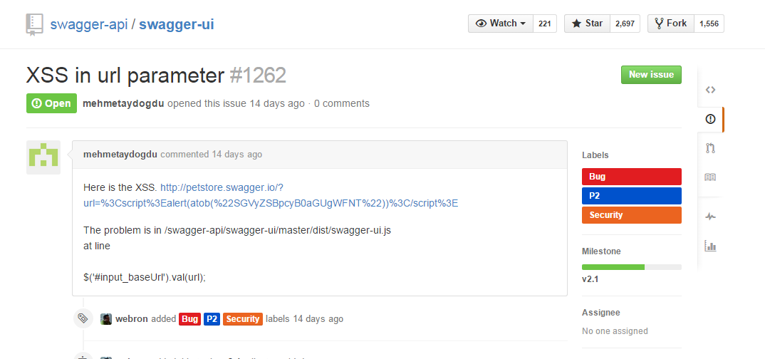

* **Additional Features**:
* add a flag that allows setting whether default values are sent or displayed only.

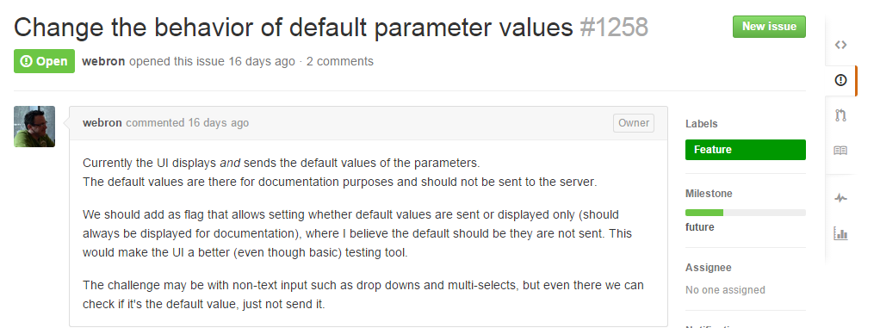

* **Regression** - config for booleanValues gone.

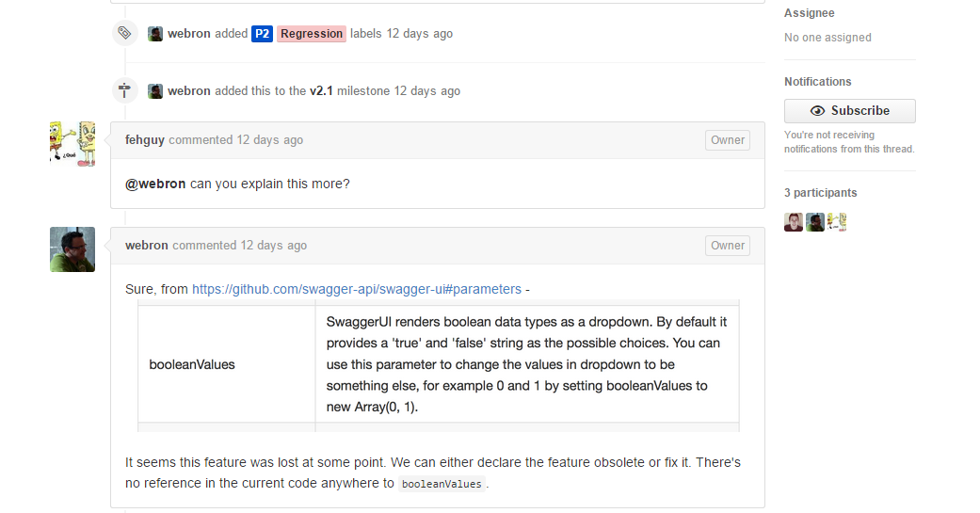

# Competitors comparison

Main competitor: **Mulesoft**

* **Not open source – can’t change the code to your needs.**
* **Cost money.**
* **Smaller community – need to wait sometimes couple of days for support from the support team.**
* **Better UI.**
* **Integration with more MuleSoft components.**
* **Dedicated support team.**

# Swagger UI main contributors

Overall 81 contributors in 4 years

